PROVISIONAL MARKING KEY
2026 SEED MSCE MOCK CHEMISTRY PAPER 11

- . With the aid of a diagram, describe the water cycle.
Some of the processes involved in water cycle are as shown below:
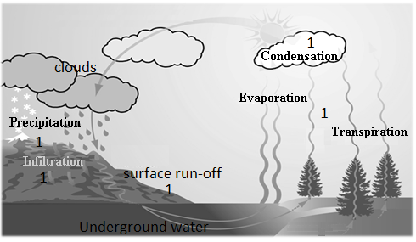
The water cycle
(1 mark for each process at a right position on the diagram. Evaporation and
And transpiration are given 1 mark)
- Evaporation and transpiration:
This is where water vapour is added into the atmosphere from water bodies and green plants respectively. 1
- Condensation:
This is where water vapour is changed into a liquid as a result of cooling. 1
- Precipitation:
Precipitation involves accumulation of clouds in the sky for many hours and the clouds become heavy. The heavy clouds release moisture back to the earth inform of rain. 1
- Infiltration:
This process involves movement of water through the soil. 1
- Surface run-off.
This is where rain water run on the surface of the earth especially after it has rained. 1

- With the aid of a diagram, describe an experiment which can be conducted to identify pure solidified water (ice) using melting point.
Procedure:
- Set up the apparatus as shown in the figure below.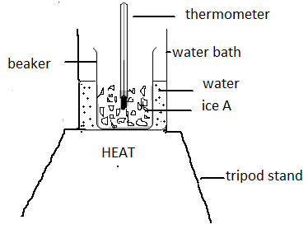
(1 mark for correct diagram, 1 mark for any correct labelling)
- Put the crushed solid particles of ice A into the beaker to a height of about 3cm. 1
- Dip the thermometer into the beaker containing ice and place it into the water bath 1
- Place the water bath on source of heat. 1
- Record the temperature at which some liquid begins to appear in the beaker. 1
- Keep the beaker in the warm water bath until all solid particles have disappeared. 1
- Record the temperature at which all the solid particles disappeared. 1
Table of results
Solidified water (ice) | Temperature it starts melting | Temperature at which all ice particles disappear
A
B

- Repeat steps (b) to (g) using ice B. 1
- Compare the melting point range for ice A and B. 1
- The ice which melts over a range of temperatures (that will have a wider melting point range) is an impure ice while the one that melts at 0⁰C is pure ice. 1
(10 marks)

SECTION B (20marks)

- Table of results
Substances | Ammeter reading
W | Any reading 1
X | 0 1
Y | 0 1
Z | Any reading 1
(4 marks)

- Classify the liquid substances W, X, Y and Z as ionic and covalent.
Ionic compounds | Covalent compounds
W 1 | X 1
Z 1 | Y 1
(4 marks)
- State two sources of errors in this experiment.
- Failure to get correct readings from the ammeter. 1
- Wrong connection of the circuit. 1
(2marks)
- Table of results
Metal/Solutions | Copper sulphate | Magnesium sulphate | Iron sulphate
Copper |  | No reaction 1 | No reaction 1
Magnesium | Reaction 1 |  | Reaction 1
Iron | Reaction 1 | No reaction 1
(6marks)
- Arrange the metals in order of decreasing reactivity.
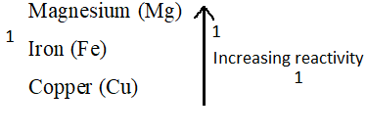
(3 marks)
- Which metal is the strongest oxidising agent?
Copper (Cu) (1 mark)

